General Manager's Report
ITEM 9.5 SF764 270122 Planning Proposal - reclassification of community land to operational land Lot 91 in DP239693 Banksia Cres Scotts Head

AUTHOR/ENQUIRIES: Grant Nelson, Coordinator Strategic Planning & Natural Resources

Summary:

The purpose of this report is to request Council commence the process involved with the reclassification of Land at Lot 91 DP239693 for the purpose of creating a future public road and providing access to Lot 2 DP417248 5 Banksia Crescent, Scotts Head.

NOTE: This matter requires a “Planning Decision” meaning a decision made in the exercise of a function of the council under the Environmental Planning and Assessment Act 1979 including a decision relating to a development application, an environmental planning instrument, a development control plan or a development contribution plan. Under Section 375A of the Local Government Act 1993 it requires the General Manager to record the names of each Councillor supporting and opposing the decision.

Recommendation:

- That pursuant to Division 3.4 of the Environmental Planning and Assessment Act 1979 it is recommended that Council proceed to reclassify the Lot 91 DP239693 from Community to Operational.

- That Council rezone the land from RE1 to R1 General Residential to provide consistency with adjoining land and road reserves.

- Council prepare a planning proposal to support the proposed amendment to the Nambucca LEP 2010 and in accordance with Division 3.4 of the Environmental Planning and Assessment Act 1979 seek a gateway determination from the Minister.

OPTIONS:

Council may choose not to proceed with the reclassification, in which case it is recommended that Council engage in negotiations with the relevant property owners to establish a lease over the land for a period not greater than 21 years.

DISCUSSION:

The owners of 5 Banksia Crescent (Lot 2 DP417248) approached Council after identifying an issue with access to their property.

A ‘right of way’ existed over Lot 1 DP417248 to benefit 5 Banksia Crescent (Lot 2 DP417248) prior to Lot 1 being subdivided. See the below plan showing a ‘right of way’.

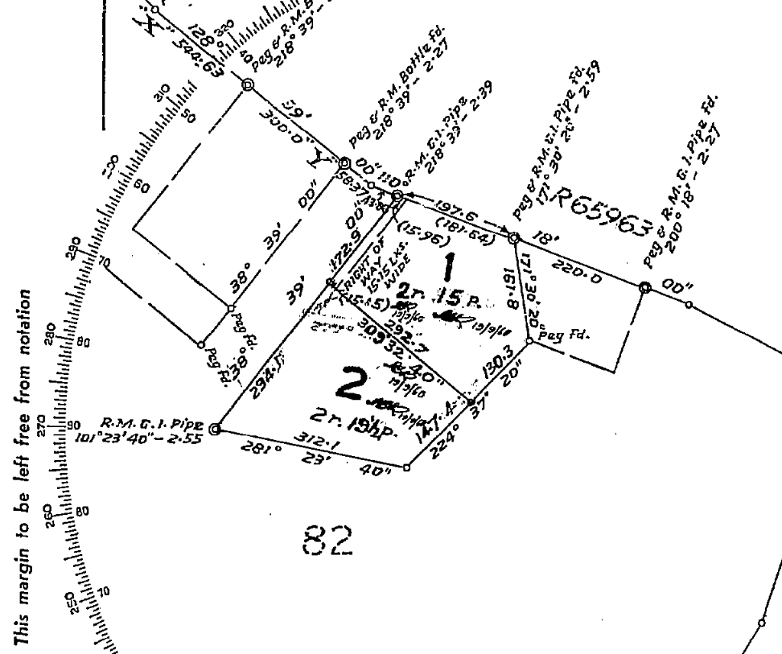

In 2011 the subdivision of Lot 1 DP417248 into 2 lots was registered creating Lots 1 and 2 DP1160534. This plan was registered without a ‘right of way’ benefiting 5 Banksia Crescent. See the below plan showing no ‘right of way’.

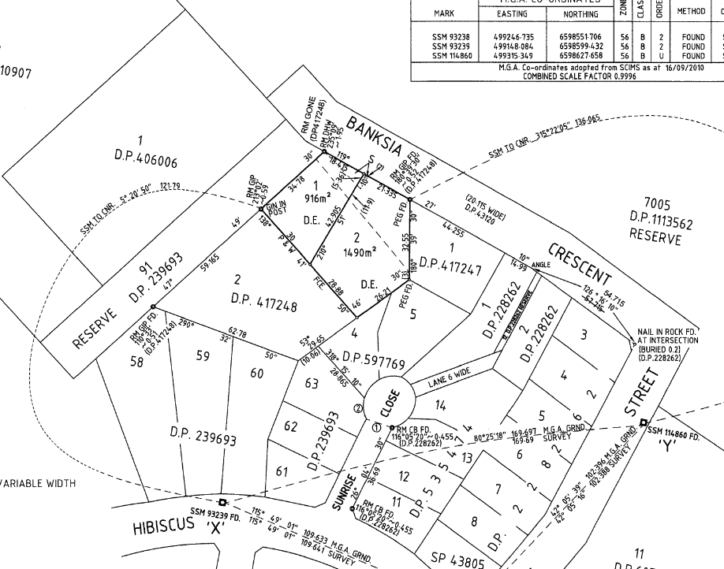

Currently the owners of 5 Banksia Crescent have no “legal” access to their property and rely on access over public reserve Lot 91 DP239693 (Subject Land) as highlighted in blue below. This land is presently classified as community land – categorised as park.

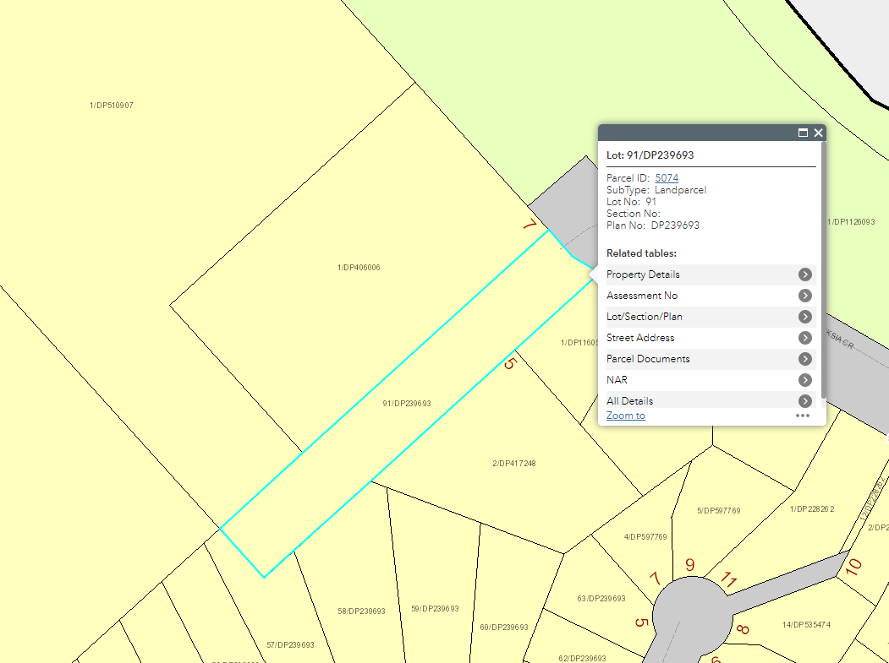

Section 47F of the Local Government Act provides that community land can’t be dedicated as a public road unless the road is necessary “to facilitate enjoyment of the area of community land on which the road is to be constructed”, and the council has considered means of access other than a public road access to facilitate that enjoyment, and there is a plan of management applying only to the land which expressly authorises the public road. Staff do not believe that Council can satisfy these requirements to dedicate the community land as public road.

Alternatives to allow access over this land include:

License agreement or lease of the community land

Council may enter a license or lease arrangement with the owners of 5 Banksia Crescent, however the license or lease arrangement is unlikely to suffice as legal access for the purposes of re-development or similar activities at 5 Banksia Crescent.

Creation of an 88K instrument

An 88K instrument may be used to provide access over the community land in accordance with the provisions of the Conveyancing Act 1919. However such a restriction requires the Supreme Court to determine the access and without investigating further is likely to be both a costly and lengthy process.

Reclassification of the adjoining public reserve from community to operational land to allow for it to be created as a public road

Pursuant to section 27 of the Local Government Act 1993, an amendment to the Nambucca LEP 2010 is required to reclassify the land from Community to Operational land.

To support such an amendment Division 3.4 of the Environmental Planning and Assessment Act 1979 indicates that a planning proposal must be prepared and submitted for Gateway Determination by the Minister. The Minister would determine any requirements of the process such as exhibition and agency consultation.

As the planning proposal would be reclassifying the land from community to operational land it is a requirement under section 29 of the Local Government Act that a public hearing be held and facilitated by an independent professional.

Should council proceed to re-classify the community land to operational it may then be dedicated as public road, through a separate process.

It is anticipated that the reclassification process would take a minimum of 6 months to complete. At this time the Council staff could pursue the road dedication.

It is recommended that Council proceed with the reclassification to provide a permanent resolution to the matter.

Other Matters

Existing Condition

The existing reserve has an informal vehicle access track established on the land providing access to 5 Banksia Crescent.

Local Environmental Plan – Zoning and Principle Development Standards

The subject land is presently zoned RE1 Public Recreation and it is proposed to amend this zone to R1 General Residential to provide consistency with the adjoining land use zones and public roads.

The subject land has no existing minimum lot size and it is not proposed to amend this FSR

The subject land has an existing FSR of 0.55:1. It is not proposed to amend this FSR.

The subject land has an existing building height restriction of 8.5m and it is not proposed amend the building height.

Road construction and maintenance

Matters relating to construction costs of the road are yet to be determined. The road will be added to Councils Asset register and asset management program and revaluation system.

Coastal Hazards and Council Assets

Banksia Crescent is one of only 2 public roads and residential areas in the Nambucca Valley that are anticipated to be impacted by Coastal Hazards. A map of the modelled coastal hazards taken from Council’s Coastal Hazard Study is presented below showing the difference between 2009 aerial photography and 2020 aerial photography.

2009
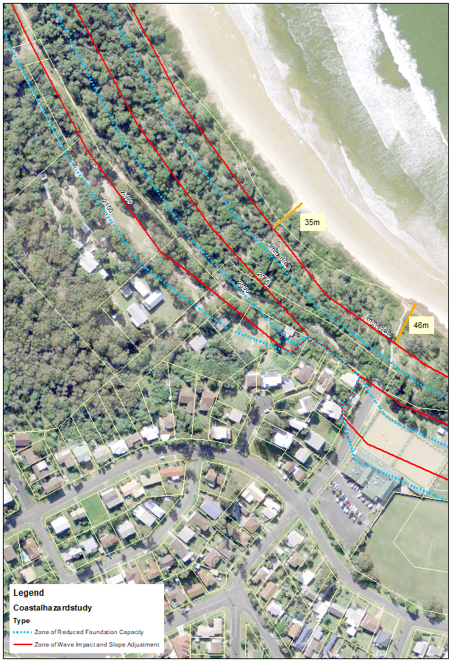

2020
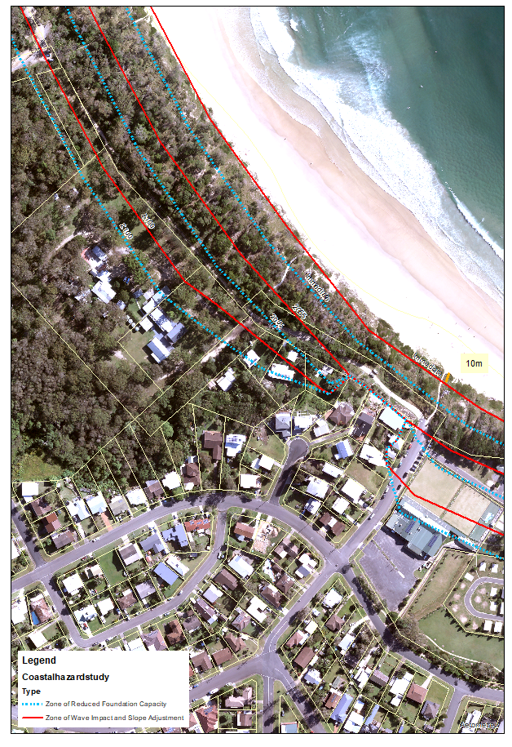

Beaches go through processes and periods of accretion and erosion which may change over time however since 2009 the fore dune has moved landward 35m (approx.) in front of the reserve subject to this reclassification and West St. This is a rate of about 2.9m per year over 12 years. Applying this rate to the 70m of dune remaining estimates it would be at Banksia Crescent by about 2045. Our hazard study predicts the zone of wave impact will be at Banksia Crescent by about 2055.

There will be an expectation that Council will protect public and private assets that may be impacted by coastal processes including roads and the recommended planning proposal may increase that expectation. But as it stands the property has no legal access.

CONSULTATION:

General Manager
Manager Development and Environment
Assistant General Manager Engineering Services
Surveyor

SUSTAINABILITY ASSESSMENT:

Environment

The environmental attributes of this land and the planning proposal are identified in the body of this report.

Social

Should a formal access to 5 Banksia Crescent not be resolved it will likely cause ongoing concern for the occupants and owners of the land. Further other nearby residents may raise concern over the illegal use of community land for a private access.

Economic

The lack of formal access to 5 Banksia Crescent, may affect the value of the property. The dedication of the land as public road and attribution to Councils asset management program will require ongoing financial commitment from Council. This may be more significant as coastal processes encroach landward.

Risk

There is limited immediate risk with the planning proposal. In the future the risk relating to asset responsibilities will be increased.

FINANCIAL IMPLICATIONS:

Direct and indirect impact on current and future budgets

Staff resources will be required to progress with the preparation of the planning proposal and the implementation actions arising from the gateway determination.

Council will be required to engage a suitably qualified professional to independently facilitate the Public Hearing required to support the reclassification process.

Other financial implications are identified in the body of this report.

Working funds – justification for urgency and cumulative impact

Nil.

Service level changes and resourcing/staff implications

Staff resources will be required to prepare the planning proposal and implement actions arising from the Gateway Determination.

Attachments:
There are no attachments for this report.

